Home
Vision: To revolutionize healthcare delivery in Tanzania and beyond by making quality, accessible, and affordable healthcare available to everyone through innovative, technology-driven, and environmentally sustainable solutions.

500,000+ Patients Served
75+ Communities Benefited
24/7 Access to Digital Healthcare

A Silent Emergency in Tanzania
Every day, thousands face impossible choices between health and survival simply because healthcare is too far away.

The Harsh Reality ANDThe Consequences REMOVE

The Healthcare Gap in SUB SAHARA COUNTRIES

OUR INNOVATION
By pairing the AI-powered "Afya Mfukoni" digital platform with zero-emission, solar-powered mobile clinics, AGKI has created a seamless "phygital" ecosystem that has already brought end-to-end medical care to over 500,000 people.
Backed by a highly scalable revenue model of subscriptions, pay-per-service, and strategic partnerships, this sustainable solution bypasses traditional infrastructure to deliver quality, high-impact healthcare directly to the doorstep.

ALL DATA AFTER OUR INNOVATION SHOULD BE REMOVED

problem
Inadequate Infrastructure and Supply Chains
Many clinics and hospitals, particularly in rural areas, operate without beds, reliable electricity, running water, or basic surgical facilities. This is compounded by weak supply chains, resulting in chronic shortages of essential medications, vaccines, and diagnostic equipment.

We transform rural healthcare 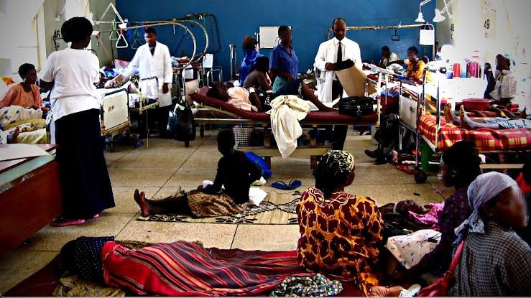
.

. Critical Shortage of Healthcare Workers
Sub-Saharan Africa bears over 20% of the global disease burden but houses only a tiny fraction of the world's healthcare workforce. The region faces a severe shortage of doctors, nurses, and midwives due to limited training capacity and "brain drain" where trained professionals emigrate to wealthier nations for better pay and working conditions.


High Out-of-Pocket Costs & Lack of Funding
Most countries in the region lack comprehensive health insurance systems. As a result, patients must pay directly for medical care, leading to extreme financial hardship or causing families to skip lifesaving treatment entirely due to cost.

SOLUTION
AGKI delivers integrated healthcare through solar-powered mobile clinics and an AI-powered digital health platform that connects patients with doctors, laboratories, pharmacies, and hospitals for appointments, diagnostics, telemedicine, digital prescriptions, and medication access. To date, we have helped over 500,000 people access quality healthcare services. Our diversified revenue model including pay-per-service, subscriptions, and strategic partnerships ensures long-term sustainability and scalable impact.

75% live far from facilities
80% avoidable deaths
$500B economic cost
O

Book Popular Specialties
Find the right specialist for your needs
How to book specialist uki select haiji
Platform Doctors kujiregister kwenye platform haikubali kwenye cheo chake
Shop (suppliyers+ Health facilities)
COMMUNITY EVENT UTAWEKA PICHA 5
pshsss

healthcare deliver

